Application form
Dynamics of Youth Events (DoY)

DoY funding promotes the organization of events with a clear relation with and added value to Dynamics of Youth.

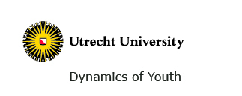

For whom?
All can apply.

What?
Open all year. Applications will be judged by the DoY program committee.

Applicant

First name
Family Name
Company/Organization

Event

Title
Starting date End date
Number of days
Place of venue
Disciplines
Estimated number of participants
Requested funding

CONTENT AND PROGRAMME

- What is the scientific aim and interest of the event (max 100 words)

- What is the envisioned group of participants?

- In what way you will promote the event? (max 100 words)

BUDGET

(overview of the full budget, in euros)

- Indicate the added value for DoY.

- Is there a reduced admission fee for researchers and collaborators of DoY for the event and if so, how has been taken care of this?

SIGNATURE OF THE APPLICANT
Full name
Date
Signature (Add your signature as a picture in jpg- or gif format)

Submission: e-mail this form to: p.m.vandijk@uu.nl
For questions contact: Petra van Dijk
p.m.vandijk@uu.nl or 030 – 253 6780

