P.INC Poster Campaign

Mail Menopause [EN]

The text below can be sent together with the banner as a campaign email. Copy-paste it in its entirety or use it as inspiration. The text in brackets can be adapted to your own input.

Use in conjunction with Banner Menopause EN (inline image as header).

---

Subject email:
Do you talk about sweaty nights with your colleagues?

Email content:

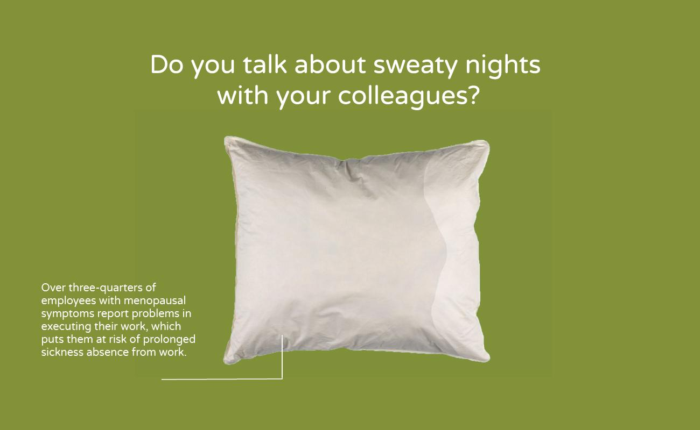

Text:
No? Would you like to?
Yes? Good that it is possible.

As an employer we value that everyone feels at home in our organization and receives the right support when they need it. But we cannot simply assume that we succeed at providing this support. What is the best way to map the experiences and needs of our employees? Do you feel free enough to share personal information such as menopausal symptoms with colleagues or superiors? Would you be comfortable to share this information with your employer for research? On [date] we are organizing an [event] to discuss this with employees. Would you like to be there?

