Transcription service
For automatic transcription of audio and video files, you can use Amberscript, ITS’ transcription service. This tool is also suitable for files with sensitive data.
Note: This is a pilot. If you want to use Amberscript, we ask you to provide one-time feedback on your experience with this new service. The pilot project will run from 17 October 2022 to 30 September 2023.
For this pilot, 1,000 audio hours have been purchased. In the pilot phase, transcription costs will not be charged. We pursue a fair use policy. Please do not request more hours than you actually need.
If the total hours budget runs out before the end of the pilot and new budget is needed, we may decide to charge for new transcription requests. We will inform you in time.
Contact person Utrecht University: Bertil Schaart, b.m.s.schaart@uu.nl
Administrator Utrecht University: transcriptie@uu.nl
Responsible organisation: ITS Research and Data Management Services

Create an account
Do you want to transcribe sensitive data? Please read Utrecht University's privacy policy before creating an account. You can find the policy here: https://tools.uu.nl/privacy_statement/transcriptie-tool-amberscript/
To create an Amberscript account, follow these steps:
Are you a student at Utrecht University and do you need this service for your research? Then your tutor should follow the procedure below.
- Go to https://app.amberscript.com/login and choose Login via SSO. Then choose Utrecht University and log in with your Solis-id.
Note: have you previously created an account directly with Amberscript outside this pilot and have you used your @uu.nl e-mail address? Then you will first have to get all your files out of your Amberscript account. Then email operations@amberscript.com requesting them to delete your account. After that, you can re-register via https://app.amberscript.com/login. Choose Login via SSO and then select Utrecht University. Then you can log in with your Solis-id.
- Your account has now been created, but is not yet linked to a faculty within Utrecht University. Therefore, please send an e-mail to the administrator of the transcription service at Transcriptie@uu.nl. In your request, write the following information:
  - the title of the research project you are working on
  - how long the audio recording(s) are that you want transcribed for your research
  - in which language/languages
  - do the recordings contain GDPR-sensitive information?
  - at which faculty you work
  - how you will further edit the automatic transcription {not, self, working student, professional, ...}
  - whether you are willing to provide feedback on your experiences with the transcription service
  - whether you are willing to measure how much time manual post-processing takes up
  - when you want to start the transcription
  - when you think you have finished transcribing (including post-editing)
The administrator will then link you to the right faculty and assign you a time budget. Once you have been notified by the administrator, you can start using Amberscript. You can read how this transcription tool works in the manual.
Is a student going to work out the automatic transcription? Then invite them to your Amberscript Team: click on your account at the top right, choose <Manage Organisation>, click on the three bullets next to your team and choose <Invite users>. You can then invite them and give them credits.
Please note: with Amberscript, only the person who uploads the files has access to those files. In other words, at this moment, you cannot work together on the same file and the files cannot be shared. The teams in Amberscript are solely for administrative purposes; you cannot share files.
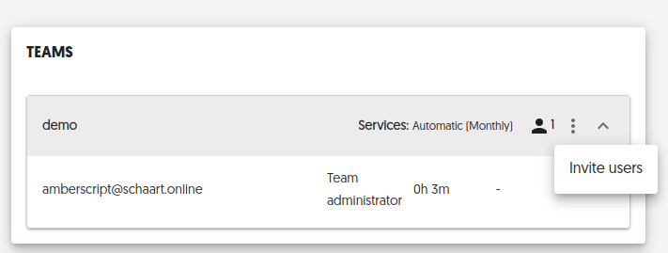

Transcribing with Amberscript
- Go to https://app.amberscript.com/login and choose Login via SSO. Next, enter the name Utrecht University and then log in with your Solis-id.
- Choose [Upload]. Watch this instructional video for more details: https://youtu.be/KZofqSc-k1s
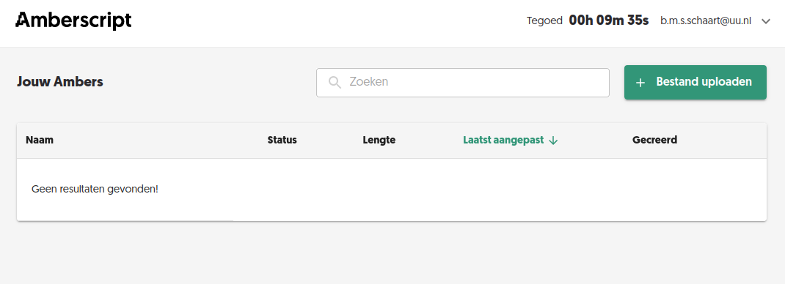
- Select the language and number of speakers. Then choose whether it is [Transcription] or [Subtitles].
- [OPTIONAL] If you have a lot of specific terms or proper names in your recordings, you can turn on the glossary. This greatly improves transcription. Click <Use glossary>, <Create new collection> and add the words.
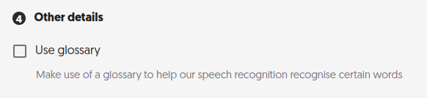
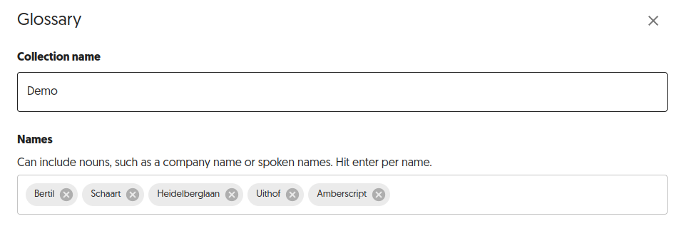

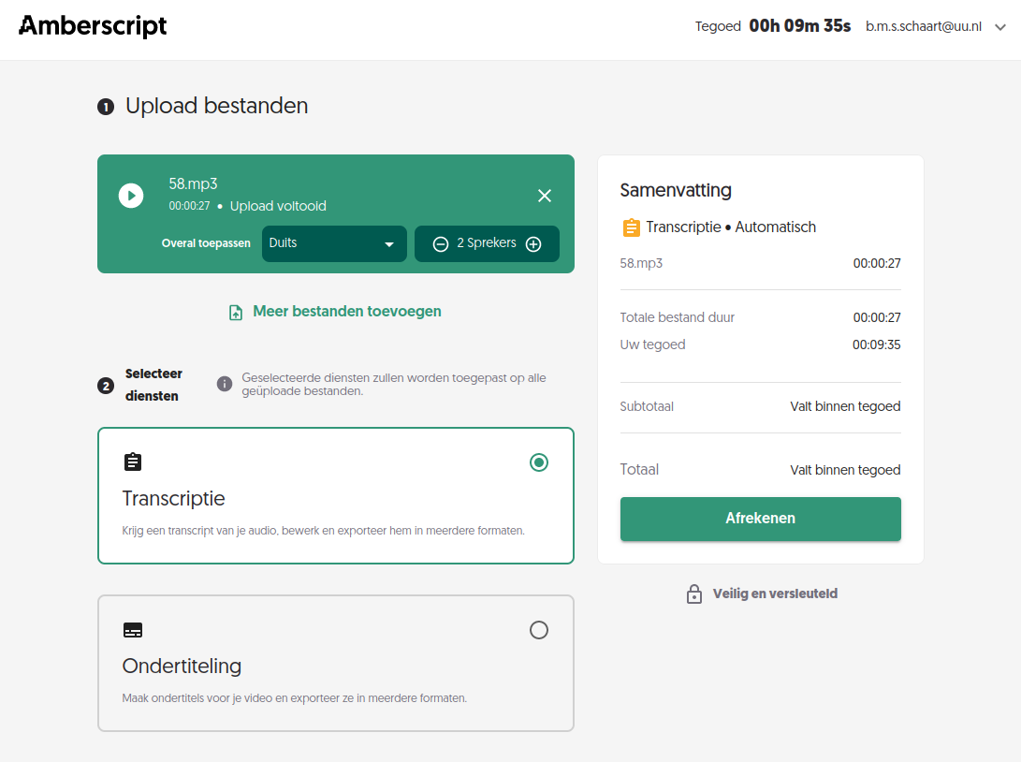
- Click on [Order]. The transcription process will now start automatically.
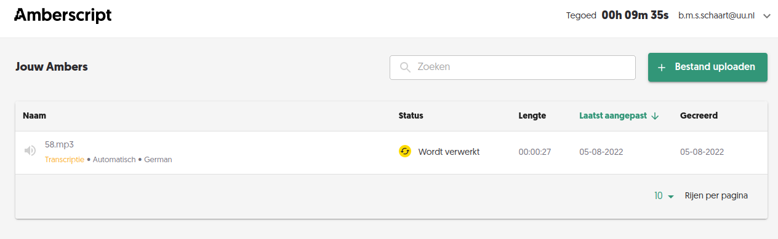
- You will receive an e-mail when the transcription is ready. In the meantime, you can upload the next audio file for transcription.
- When the transcription is ready, you can edit it manually. You can see how to do this in this video: https://youtu.be/Ay2mFabfiEc
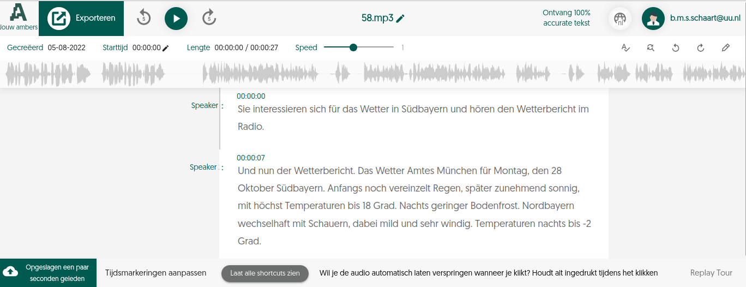
- After editing, click [Export] to download the text file. This video explains how to do it: https://youtu.be/319ja9UH0UQ
- When you have finished editing and downloaded the files, you must delete the text files and audio files from Amberscript because of privacy rules. When doing so, make sure you save the downloaded files in the right place and remove them from the download folder.
- For privacy reasons, you should not wait too long before starting manual editing. This prevents audio files containing sensitive information from being unnecessarily long on Amberscript's server.

Advice

- The speed of automatic transcription depends on how busy the Amberscript server is. In your planning, allow for one hour of processing time per audio file. In practice, it will usually be faster.
- Automatic transcription has an accuracy rate of about 85%-90%. To improve the transcribed text, edit it manually. This obviously takes time, depending on the desired result. We would love to hear about your experiences. Please send them to: transcriptie@uu.nl.
- The length of the audio file naturally determines the processing time required, but other factors also come into play; accents, speed of speech, how clearly someone talks, the use of terminology not recognised by the programme, etc.

