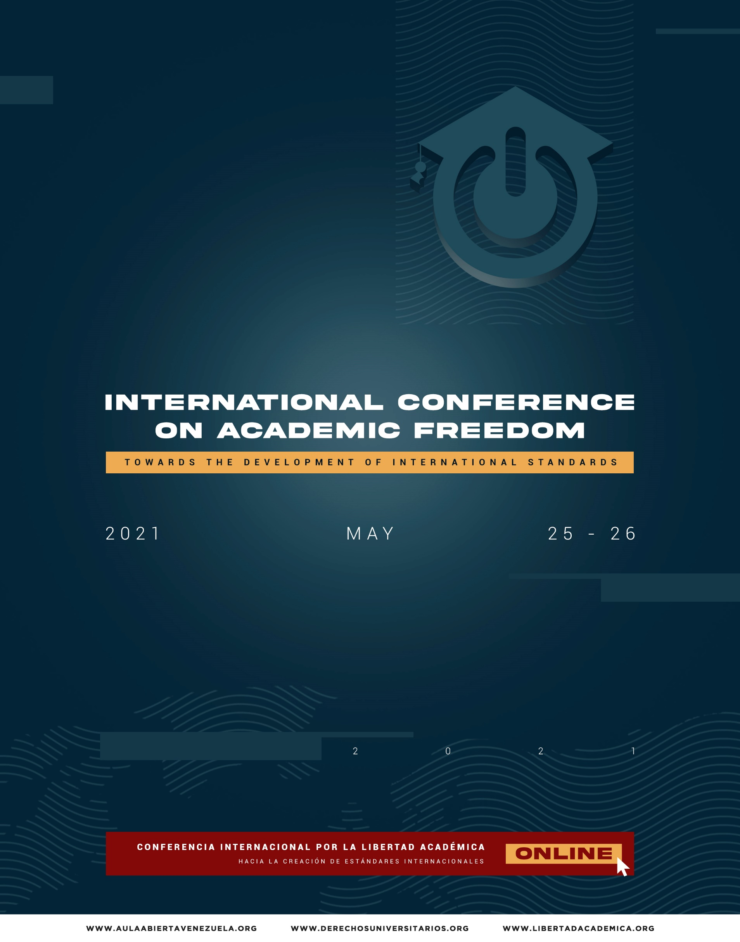

PRELIMINARY AGENDA

May 25, 2021
DISCUSSION PANEL: INTERNATIONAL STANDARDS ON ACADEMIC FREEDOM AND UNIVERSITY AUTONOMY: A PENDING COMMITMENT. (English)

Hosted by: David Gomez Gamboa (General Director of Aula Abierta); Mayda Hocevar (Director of the ULA Human Rights Observatory); and Ricardo Villalobos (International Research and Advocacy Coordinator of Aula Abierta).
- Clement Voulé. United Nations Special Rapporteur for the Rights of Freedom of Peaceful Assembly and Association. Topic: Academic freedom and the United Nations Special Rapporteur for Freedom of Peaceful Assembly and Association.
- David Kaye. Former Rapporteur for Freedom of Opinion and Expression of the United Nations (UN). Topic: Main considerations of the 2020 report “Promotion and protection of the right to freedom of opinion and expression in the context of academic freedom”. -TO BE CONFIRMED-
- David Gomez Gamboa. University professor, General Director of Aula Abierta and Coordinator of the Human Rights Commission of the University of Zulia. Topic: Patterns of violation of academic freedom in Latin America. / Pending challenges in the jurisprudence of the Inter-American Court.
9:15 AM - 11:30 AM

(GMT -4).
- Antoine Buyse. Professor and Director of the Netherlands Institute for Human Rights at Utrecht University. Topic: Situation of academic freedom in the Netherlands / Utrecht Declaration of Academic Freedom.
- Carla Ferstman. Professor at the University of Essex. Topic: Academic Freedom: Challenges in Europe.
- Ricardo Villalobos. Professor at the Rafael Urdaneta University. Coordinator of Research and International Advocacy of Aula Abierta. Topic: International incidence on academic freedom.
- Jose Gustavo Prieto. Postdoctoral researcher at the Department of European, Public and International Law at the University of Ghent. Topic: Right to academic freedom in Ecuador.
- Pam Fredman. President of the International Association of Universities (France). Topic: The future of Universities in Europe.
DISCUSSION PANEL: OVERVIEW OF ACADEMIC FREEDOM AND UNIVERSITY AUTONOMY IN LATIN AMERICA. (Spanish)

Hosted by: Karla Velazco (Professor at the University of Zulia and the Rafael Urdaneta University.
Sub-Director of Aula Abierta Projects).

- ARGENTINA. Pablo Riberi. Argentine professor at the University of Cordoba. Topic: Rethinking the Argentine University: Education, Academic Freedom and Free Deliberation.
- MEXICO: Elba Jimenez. Professor at the National Autonomous University of Mexico (UNAM). Topic: Restrictions on university autonomy in Mexico.
- CUBA: Jose Raul Gallegos. Cuban journalist, professor, and researcher.
Topic: Threats to academic freedom in Cuba.
- HONDURAS: Joaquin Mejia Rivero. Lawyer and professor at the National University of Honduras. Topic: Academic freedom and university autonomy in Honduras.
11:30 AM - 01:00 PM

(GMT -4).
- VENEZUELA: Innes Faria. University professor. Chief Editor of the Journal of Juridical Issues of the Rafael Urdaneta University. Topic: Restrictions for university autonomy and academic freedom in Venezuela.
- BOLIVIA: Marco Baldivieso. Lawyer, university professor, (former) Dean of the Constitutional Court of Bolivia. Topic: Right to academic freedom in Bolivia.
- COLOMBIA: Nastassja Rojas. Dean of the Faculty of Legal and Political Sciences of the University of St. Thomas. Topic: Academic Freedom in Colombia.
DISCUSSION PANEL: ACADEMIC FREEDOM AND ITS RELATIONSHIP WITH FUNDAMENTAL FREEDOMS. (Spanish)

Hosted by: Sergio Angel Baquero. (Associate Professor of the School of Politics and International Relations of the Sergio Arboleda University).
SPECIAL PRESENTATION: AHMED SHAHEED. UNITED NATIONS SPECIAL RAPPORTEUR ON FREEDOM OF THOUGHT, RELIGION OR BELIEF

Opening panel with special presentation by Ahmed Shaheed. United Nations Special Rapporteur on freedom of thought, religion, or belief. Hosted by: Ricardo Villalobos (Professor at the Rafael Urdaneta University. Coordinator of Research and International Advocacy at Aula Abierta).

- Tulio Alvarez. Professor at the Central University of Venezuela and the Andres Bello Catholic University. Topic: Violations of academic freedom and freedom of expression in the Tulio Alvarez case before the Inter-American Court of Human Rights.
- Marcia Ibarra. Sub-Director of the Center for Research and Health Studies of the National Autonomous University of Nicaragua, Managua (CIES-UNAN). Topic: Academic freedom threatened in the framework of COVID-19 in Nicaragua.
02:00 PM - 03:40 PM

(GMT -4).
- Andrea Santacruz. University professor. Director of the Human Rights Center of the Metropolitan University (UNIMET). Topic: Criminalization of the protest of university students and crimes against humanity.
- Carelia Hidalgo. Professor at the Federal University of Rio Grande (Brazil). Topic: Environmental rights and University in Brazil.
- Ali Daniels. University professor and Director of the Non-Governmental Organization “Acceso a la Justicia”. Topic: Criminalization against university students and possible commission of crimes against humanity in Venezuela.
- Eduardo Trujillo. University professor. Director of the Human Rights Center of the Andres Bello Catholic University. Topic: Financing of

academic spaces regarding the 001-2021 of the National Office against Organized Crime and Financing of Terrorism of Venezuela.
- Hildebrando Arangu. Professor at the Centroccidental University Lisandro Alvarado (UCLA). Topic: Environmental rights in the university field.
- Omara Ruiz Urquiola. Former professor at the University of Havana (Cuba). Topic: Freedom of association and Academic Freedom in Cuba.
DISCUSSION PANEL: ACADEMIC FREEDOM, UNIVERSITIES AND DEMOCRACY. (Spanish)

Hosted by: David Gomez Gamboa. (General Director of Aula Abierta).

- Flavia Piovesan. Second Vice President of the Inter-American Commission on Human Rights. Topic: -To be defined-.
- Mariela Morales. University Professor and Consultant for Latin America at the Max Planck Institute for Comparative Public Law and International Law (Germany). Topic: The role of the Academy in the Democratic Society.
03:40 PM - 04:30 PM

(GMT -4).
- Eduardo Ferrer Mc-Gregor. Mexican jurist, academic and professor. Former president of the Inter-American Court of Human Rights (IACHR).-To be confirmed-
- Catalina Botero. Former Rapporteur for Freedom of Expression of the IACHR. Topic: Freedom of expression and academic freedom: fundamental elements in democratic societies.

May 26, 2021
DISCUSSION PANEL: UNIVERSITY AUTONOMY: INTERNATIONAL PERSPECTIVE. (Spanish)

Hosted by: Mayda Hocevar (Director of the ULA Human Rights Observatory); and David Gómez Gamboa (General Director of Aula Abierta)
- Mario Bonucci. Rector of the Universidad de los Andes. Topic: Budget suffocation against the Venezuelan university and destruction of the academy.
- Cecilia Garcia Arocha. Rector of the Central University of Venezuela. Topic: Policies of persecution against AVERU and university authorities in Venezuela.
- Waldo Albarracín. Former rector of the Higher University of San Andrés (UMSA in its Spanish acronym). Topic: University autonomy in Bolivia.
- Ennio Vivaldi. Rector of the University of Chile. Topic: University Autonomy in Chile. -TO BE CONFIRMED-
9:15 AM - 11:30 AM

(GMT -4).
- Jessy Divo. Rector of the University of Carabobo. -To be confirmed-.
- Diana Romero La Roche. Dean of the Faculty of Legal and Political Sciences of the University of Zulia. Topic: University autonomy kidnapped in Venezuela.
- Karla Velazco. Professor at the University of Zulia and the Rafael Urdaneta University. Deputy Director of Aula Abierta Projects. Topic: University autonomy and Academic freedom: A relationship from means to end.
- Freddy Quezada. Former professor at the National Autonomous University of Nicaragua (UNAN). Topic: Case of expulsion from UNAN.

SPECIAL PRESENTATION: SOLEDAD GARCIA MUÑOZ. SPECIAL RAPPORTEUR ON ECONOMIC, SOCIAL, CULTURAL AND ENVIRONMENTAL RIGHTS OF THE IACHR. TOPIC: ACADEMIC FREEDOM AND THE ESCER RAPPORTEURSHIP.

Special presentation: Soledad Garcia Muñoz. Special Rapporteur on Economic, Social, Cultural and Environmental Rights of the IACHR. Topic: Academic freedom and the ESCER Rapporteurship.
11:30 AM - 11:45 AM

(GMT -4).

DISCUSSION PANEL: CHALLENGES FOR ACADEMIC FREEDOM IN THE INTERNATIONAL CONTEXT. (English)

Hosted by: Antoine Buyse (Professor and Director of the Netherlands Institute for Human Rights of the Utrecht University); and David Gómez Gamboa (General Director of Aula Abierta)

- Armando Chaguaceda. Cuban researcher at the Center for Ibero- American Constitutional Studies Member of Amnesty International Mexico. Topic: Ideological biases and threats to academic freedom in Latin America.
- Benjamin Scharifker. Rector of the Metropolitan University of Caracas. Topic: Scientific research and academic freedom: pending commitment in Venezuela.
- Ülkü Doğanay. Former professor at the University of Ankara (Turkey).
Topic: Academic Freedom in Turkey.
11:45 AM - 01:15 PM

(GMT -4).
- Maggi WH Lung. Associate Professor of International Development Studies in the Department of Human Geography and Spatial Planning, Utrecht University. Topic: Situation in Hong Kong, concerns related to COVID-19.
- Lizzy Van Dijk. Project officer of the “Shelter City Utrecht” program. Topic: Forced migration of academics: Realities and challenges.
- Rika Theo. Journalist and researcher at the University of Utrecht. Topic: Indonesian academics in exile and their intergenerational interactions with young Indonesians in Europe.
- Ariel Ruiz Urquiola. Biologist. Former professor at the University of Havana (Cuba). Topic: Indoctrination policy in Cuban universities.
- Student representative -To be defined-.
DISCUSSION PANEL: PHILOSOPHICAL AND HISTORICAL CONCEPTIONS OF ACADEMIC FREEDOM. (Spanish)

Hosted by: Juan Carlos Barreto (Director of the Center for Peace and Human Rights of the Central University of Venezuela); and Karla Velazco (Sub-Director of Aula Abierta Projects).

- Sergio Angel Baquero. Associate Professor of the School of Politics and International Relations of the Sergio Arboleda University (Colombia). Topic: Trends in the literature on academic freedom in the main
scientific journals
02:00 PM - 03:15 PM

(GMT -4).
- Mayda Hocevar. Professor at the University of Los Andes (ULA). Director of the Human Rights Observatory of the ULA. Topic: Academic freedom, historical references. Philosophical conceptions.
- Angel Lombardi. University professor and historian. Topic: The University in the history of humanity.
- Carlos Lusverti. Professor at the Andres Bello Catholic University (UCAB), Coordinator of the UCAB Center for Human Rights. Topic: Rule of Law, Democracy and Academic Freedom.

DISCUSSION PANEL. INCLUSIVE UNIVERSITY: RIGHT TO EQUALITY AND NON-DISCRIMINATION. (Spanish)

Hosted by: David Gómez Gamboa (General Director of Aula Abierta); and Ricardo Villalobos
(International Research and International Advocacy Coordinator of Aula Abierta).

- Pastor Elías Murillo. Former Vice-Chairman of the United Nations Committee for the Elimination of Racial Discrimination. Topic: Special focus on people of African descent.
- Monica Godoy. Colombian university professor and activist for gender rights. Topic: Gender violence in Colombian universities. / Monica Godoy case sentenced by the Colombian Constitutional Court.
- Dhayana Fernandez Matos. Professor at the Central University of Venezuela (UCV). -Topic to be defined-
- Edward Perez. Legal advisor to the Center for Reproductive Rights. Lawyer specialized in International Law. Topic: The right to an education free of sexual violence in the university context.
03:15 PM - 04:30 PM

(GMT -4).
- Beatriz Borges. Director of the Center for Justice and Peace (CEPAZ).
Topic: University spaces free of gender violence.
- Ligia Bolivar. Professor at the Andres Bello Catholic University (UCAB). Topic: Forced migration of academics.
- Isabel Zerpa. Director of the Center for Women's Studies of the Central University of Venezuela (CEM - UCV). -Topic to be defined-
- Hisvet Fernandez. Professor at the University of Los Andes (ULA).
Topic: The university protocol against gender violence.
- Yolima Arellano. Professor at the University of Los Andes (ULA). Topic: Rights of vulnerable people and groups within universities. Protocol for psychosocial care.

CLOSING ACTIVITY.

Exhibition of manifesto of the university community and civil society in favor of the creation of international standards for the protection of academic freedom.
04:30 PM - 04:45 PM

(GMT -4).

