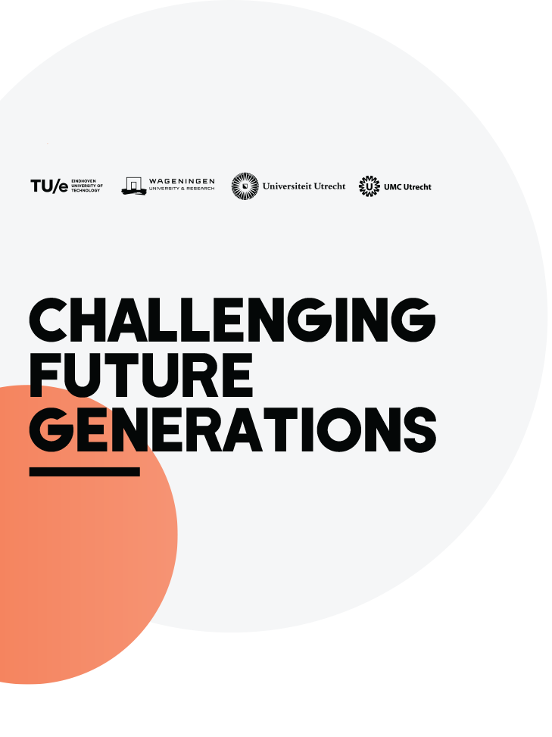

Unusual Collaborations Grants
The call for Unusual Collaborations Grants is open to proposals with budgets between €50.000 - €300.000. These grants are designed to take an idea or project further by enabling innovative, interdisciplinary science and scholarship that aims for societal impact. An Unusual Collaborations Grant provides funding for one year with the idea that the project will extend beyond the initial funding period. Teams can apply for additional funding in following rounds if the collaboration is successful.

Unusual Collaborations Grants can, for example, be used for Centre for Unusual Collaborations (CUCo) Fellowships (i.e. a part-time position as an Alliance Fellow, e.g. 0.2 fte); for organizing events or workshops; for field trips and travel and accommodation costs associated with the project; for hiring external personnel and support coaches, assistants, experts, etc. (NB: grants cannot be used towards hiring PhD students); for buying or hiring materials or services to help perform the research (i.e. equipment, data, transcription); and, for education or training, including student teams or internships.

Eligibility
For the 2020 call for proposals, teams that have participated in the Alliance-organized meetings in Utrecht and Ede, and the webinar, are eligible to apply. These meetings facilitated the formation of unusual interdisciplinary teams to address societal problems.

- The core team must include researchers from at least 3 institutes of the Strategic Alliance (TU/e, Utrecht University, UMC Utrecht, and Wageningen University).
- The main applicant has to be a member of the institutional Young Academy or one of the “Plus-Ones” (indication of nomination).

The procedure is as follows:
- September 2020: call opens
- 1 November 2020: deadline for expression of intent to submit a proposal. Submit abstract (max. 500 words) + budget + list of applicants.
- 16 November 2020: Mandatory meeting of main applicants of each project with the Centre for Unusual Collaborations in Utrecht. Please bring a draft budget
- 1 December 2020: Deadline submission of proposal (incl. budget)

The main applicant will receive written feedback by 31 January 2021. If the proposal is approved, the project will start by 1 March 2021. Funds should be spent by 31 December 2021. As noted above, multi-year collaborations are encouraged but budgets will be assessed on a year to year basis.

Evaluation process
Grant proposal evaluations are coordinated by the Centre for Unusual Collaborations (CuCo). A select number of members of the Young Academies of WUR, TU/e, UU and UMCU will be appointed to (peer) review the submissions and provide a rank score (1-7) based on the review criteria (please see below).

The Board of the CuCo will make the final decision using the YA ranking as advice. CuCo Board Members who have a direct conflict of interest (e.g., own involvement in a proposal) withhold from decision-making.

Applicants will receive written feedback for the implementation (in the case of a positive decision) or recommendations for revision (in the case of a negative decision). Teams whose proposals are rejected are encouraged to submit a revised proposal (with inclusion of a cover letter explaining how written feedback is now incorporated) for a subsequent deadline.

Review criteria
Proposals will be evaluated according to 5 dimensions:
- Proposals must address societal challenges.
- In reviewing the proposals, attention will be paid to innovation and originality, as well as to the unusual nature of the proposal. This means that a high risk, high gain (e.g. learning from failure) set up is encouraged.
- The interdisciplinary nature of the project (applicants should show how insights from different disciplines will be combined and integrated so that the result is MORE than the sum of the individual disciplines).
- The composition of the project team: we encourage diversity, inclusivity, and bringing together people who would otherwise not cooperate. Additionally, emphasis on Involvement of Early Stage Researchers (ESRs) in the project is strongly encouraged.
- The justification of the budget specifying how costs will be divided across all participating institutes.
  - Note that during the evaluation, the Centre for Unusual Collaborations can adjust proposed budgets if deemed reasonable, also to be able to fund an additional proposal.

Follow up:
As a condition of funding, recipient teams have to give an update about their progress at one of the CuCo networking events. Note that these will be hosted regularly throughout the year. These presentations are also an opportunity to receive feedback, or ask for input.

All recipient teams are expected to give a final presentation at the Centre as part of the end of the year review meeting. Before December 31, 2021, each team must hand in a brief report to the Centre for Unusual Collaborations. The CuCo coordinator will keep in touch with the project team to help them move forward with the collaboration and will organize support, training, etc. Teams are encouraged to approach the Centre about roadblocks, complications, and other issues hindering the process.

Unusual Collaborations Grant Application Form

1. a. MAIN APPLICANT
Please appoint one member of the team to serve as the main contact and coordinator of the project

Personal details

Title(s), first name(s), surname(s):
Institute, department, and/or research discipline:
Address:
Telephone number:
E-mail address:

Main expertise and research interests of main applicant
Indicate main expertise (max. 5 keywords) and summarize research done in the last 5 years (max. 300 words)

Main expertise
Summary of research:

1. b. CO-APPLICANT
Minimal requirement is 3 (co)applicants from 3 separate institutions of the Alliance; duplicate the tables below for additional co-applicants

Personal details

Title(s), first name(s), surname(s):
Institute, discipline and department:
Address:
Telephone number:
E-mail address:

Main expertise and research interests
Indicate main expertise (max. 5 keywords) and summarize research done in the last 5 years (max. 300 words)

Main expertise
Summary of research:

2. THEME

Which of the general themes of the Alliance will be addressed by the proposed collaborative project? (choose as many as apply):
☐ Health
☐ Food
☐ Energy
☐ Circular Society

3. TITLE:
Title of project:

4. KEY WORDS:

Max. 6.
Keywords for project:

5. ABSTRACT

Describe the idea/project, the societal challenge it addresses, and how the collaboration team will address it with a new, unusual approach. Max. 500 words, address a general audience.
Abstract

6. DESCRIPTION OF THE PROJECT: EXECUTION AND COLLABORATION

Describe here the project in more detail: its background, context, the specific questions the project wants to address and how you want to go about it (design, methodology, and approach). Explain what each of the applicants brings to the project and how the combined expertise of the applicants can optimally address the topic and the societal problem in question. What is unusual about your collaboration? What societal partners can you envision working with? How are diversity and inclusion addressed in the project? Max. 2500 words.
Explanation:

7. TIMELINE

Please complete the Gantt chart and adjust to your collaboration

Activities (Month) | 1 | 2 | 3 | 4 | 5 | 6 | 7 | 8 | 9 | 10 | 11 | 12

8. DETAILED BUDGET
Budget should include costs for:
- Centre of Unusual Collaborations Fellowships: A part-time position for core members of the project team, e.g., 0.2 fte.
- Detailed first year budget
Additionally, the budget can include costs for:
- Hiring external personnel
- Funds for education, including student teams or internships
- Buying or hiring materials or services to perform the research
- Travel costs associated with the project
- Multi-year budget vision, if applicable (amount per year; specify any external funding)

(Please identify, to the best of your ability, which costs are attributed to which institute and that approximately 5% of the budget is dedicated to outreach and dissemination (e.g. video, policy brief, infographics, etc.).

Detailed budget first year | Estimated costs | Recipient Institution
Personnel
Materials
Total costs:

“Plus Ones” are young researchers at the four alliance institutes who are not members of the Young Academies but who are invited to join a collaboration team. It is the mission of the Young Academies of the Alliance to be as open and inviting as possible in the process of creating unusual collaborations between the four institutes.
This step has been included as a way of not only ensuring that only eligible teams prepare the full proposal, but also to provide insight into how much money teams are requesting, with a view towards fair and broad distribution. See review criteria (5.a for a note on budgetary adjustments).

