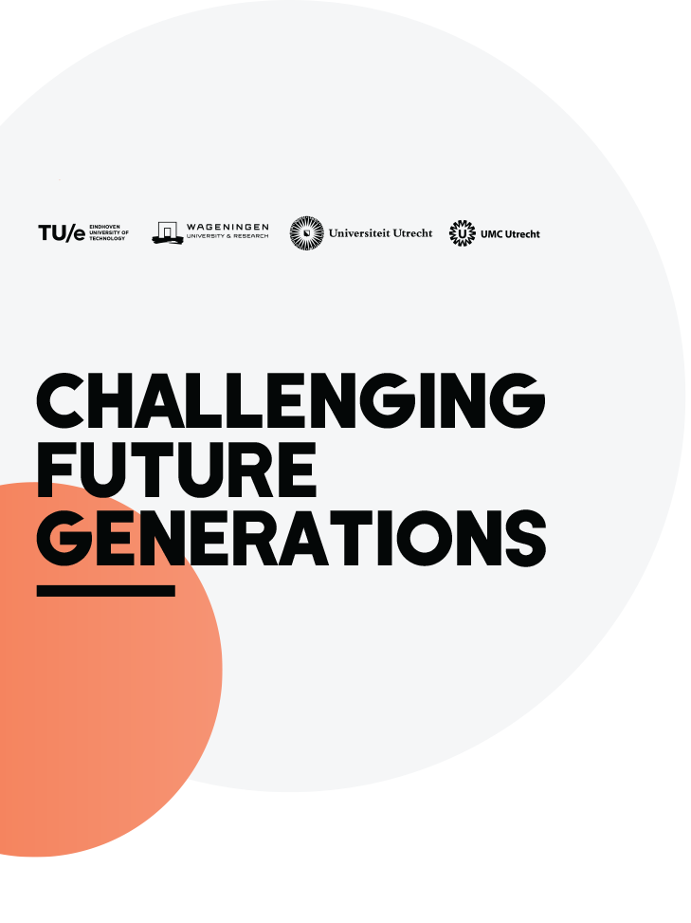

Spark Grants
Spark Grants (up to €9000) aim to stimulate unusual collaborations to address societal challenges related to health, food, energy, and circular society. The grants do this by offering initial financial support to start building committed project teams so as to explore and develop new ideas. The grants are thus a low-threshold stimulus to start collaboration, to share knowledge and best practices, and to develop something together. Spark Grants can be used to explore the feasibility of an idea or possible project and/or to test whether it can be taken further and developed into an application for an Unusual Collaborations Grant.

Spark Grants can be used, for example, to finance meetings and events, assistants or other support, facilitators or coaches, field trips, etc. Funding should be spent within 1 year after it has been granted.

A Spark Grant is a prerequisite for applying for the larger Unusual Collaborations Grant.

The procedure is as follows:
  - Attend a Centre for Unusual Collaborations (CuCo) Networking event (these are held throughout the year)
  - Pitch an idea/vision
    - Pitch format: 5-minute presentation or video + 10-minute discussion.
    - Pitches should highlight how the idea is not strictly the advancement of an individual research project expanded to include others, but rather ideas that could be further developed through collaboration and thinking together.
  - Form an unusual team (must include at least 3 institutes of the Alliance – please consult the Eligibility section below for important information)

Once you have identified a team, submit a proposal using the application form below.

Once the grant is approved, teams can start spending the funding. Note that funding is based on reimbursements of costs.

Submission
The call for Spark Grants opens in September 2020. There will be three submission deadlines:
- 1 February, 2021
- 1 May, 2021
- 1 September, 2021

Please use the application form template below.

Eligibility
- The core team must include researchers from at least 3 institutes of the Strategic Alliance (TU/e, Utrecht University, UMC Utrecht, and Wageningen University).
- At least one of the main applicants has to be a member of the institutional Young Academies.

Evaluation
Spark Grant applications are considered 3 times a year by the Board of the CuCo. CuCo Board Members who have a direct conflict of interest (e.g., own involvement in a proposal) withhold from decision-making.

Applicants can expect to receive a decision within 1 month of the submission deadline, along with written feedback for the implementation (in the case of a positive decision), or recommendations for revision (in the case of a negative decision).

Teams whose proposals are rejected are encouraged to submit a revised proposal for a subsequent deadline. Resubmitted applications should include a cover letter explaining the changes made in respect to the first application.

Evaluation Criteria
Proposals will be evaluated according to the following criteria:
- Project idea:
  - new, unique, unusual
  - interdisciplinary
  - addresses societal challenges in at least one of the themes health, food, energy, or circular society
- Prospect, eligibility and diversity of the proposed team
- Alignment with the objectives of the Centre

Follow up:
Spark Grant recipients are asked to give an update about their progress at one of the CuCo networking events (ideally after half a year). This is an opportunity to receive feedback, get new members on board, or ask for input.

At the end of the year review meeting of the CuCo, Spark Grant recipients will be asked to give a brief final presentation. Before December 31, 2021, each team must hand in a brief report to the Centre for Unusual Collaborations. The CuCo coordinator will keep in touch with the project team to help them move forward with the collaboration and will organize support, training, etc. Teams are encouraged to approach the Centre about roadblocks, complications, and other issues hindering the process. Discontinuing projects that end up not being feasible is okay, as this will provide budget for others to start up new projects.

Spark Grant Application Form

1. a. MAIN APPLICANT
Please appoint one of the team members to serve as main contact and coordinator of the project

Personal details

First name(s), surname(s):
Alliance member:
Institute, department:
Address:
Telephone number:
E-mail address:

Main expertise and research interests of main applicant
Indicate main expertise (max. 5 keywords) and summarize research done in the last 5 years (max. 300 words)

Main expertise
Summary of research:

1. b. CO-APPLICANTS
Minimal requirement is 3 (co)applicants from 3 separate institutions of the Alliance; duplicate tables below for as many additional co-applicants as you would like to add

Personal details Co-Applicant

First name(s), surname(s):
Alliance member:
Institute, department
Address:
Telephone number:
E-mail address:

Main expertise and research interests
Indicate main expertise (max. 5 keywords) and summarize research done in the last 5 years (max. 300 words)

Main expertise
Summary of research:

2. THEME

Which of the general themes of the Alliance will be addressed by the proposed collaborative project? (choose all that apply):
☐ Health
☐ Food
☐ Energy
☐ Circular Society

3. TITLE:
Title of project:

4. KEY WORDS:

Max. 6.
Keywords for project:

5. ABSTRACT

Describe the idea/project, the societal challenge it addresses, and how the collaboration team will address it with a new, unusual approach. Max. 500 words, address a general audience.
Abstract

6. COLLABORATION
Explain how the project idea developed in a collaborative fashion. Highlight what each of the applicants brings to the project/idea and how the combined expertise of the applicants can optimally address the societal problem in question. Max. 500 words.

Explanation:

7. PRACTICALITIES OF THE PROJECT
Use this space to provide additional information about how you want to approach your idea/project/challenge, for example:
Project-specific questions and approaches:
Design, methods, procedure:
How you intend to use the budget:

8. TIMELINE

Activities (Month) | 1 | 2 | 3 | 4 | 5 | 6 | 7 | 8 | 9 | 10 | 11 | 12
Please complete the Gantt chart and adjust to your collaborations

9. DETAILED BUDGET
Budget can include costs for: meetings (incl. travel costs and hotel stay), facilitator or coach, assistant, media support (e.g. for animation or for making a video clip to bring ideas for the project across, and/or pilot work, etc.

Budget item | Estimated costs
Personnel
Materials
Total costs:

